FOUNDATION 1

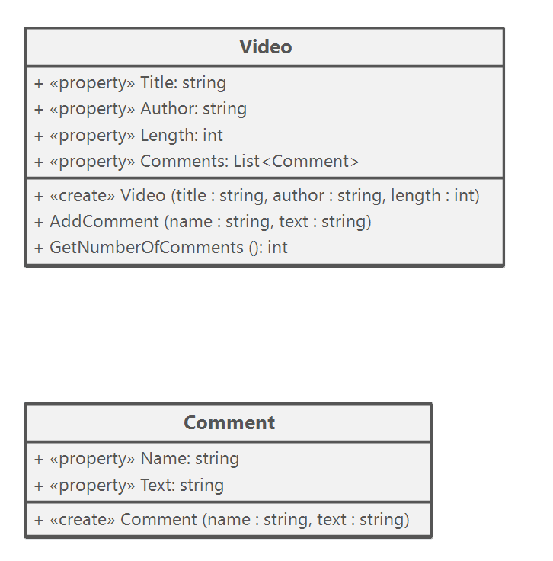Abstraction with YouTube Videos

FOUNDATION 2

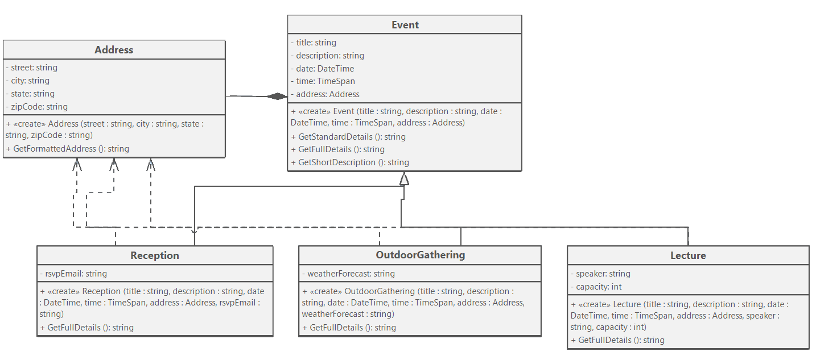Encapsulation with Online Ordering

FOUNDATION 3

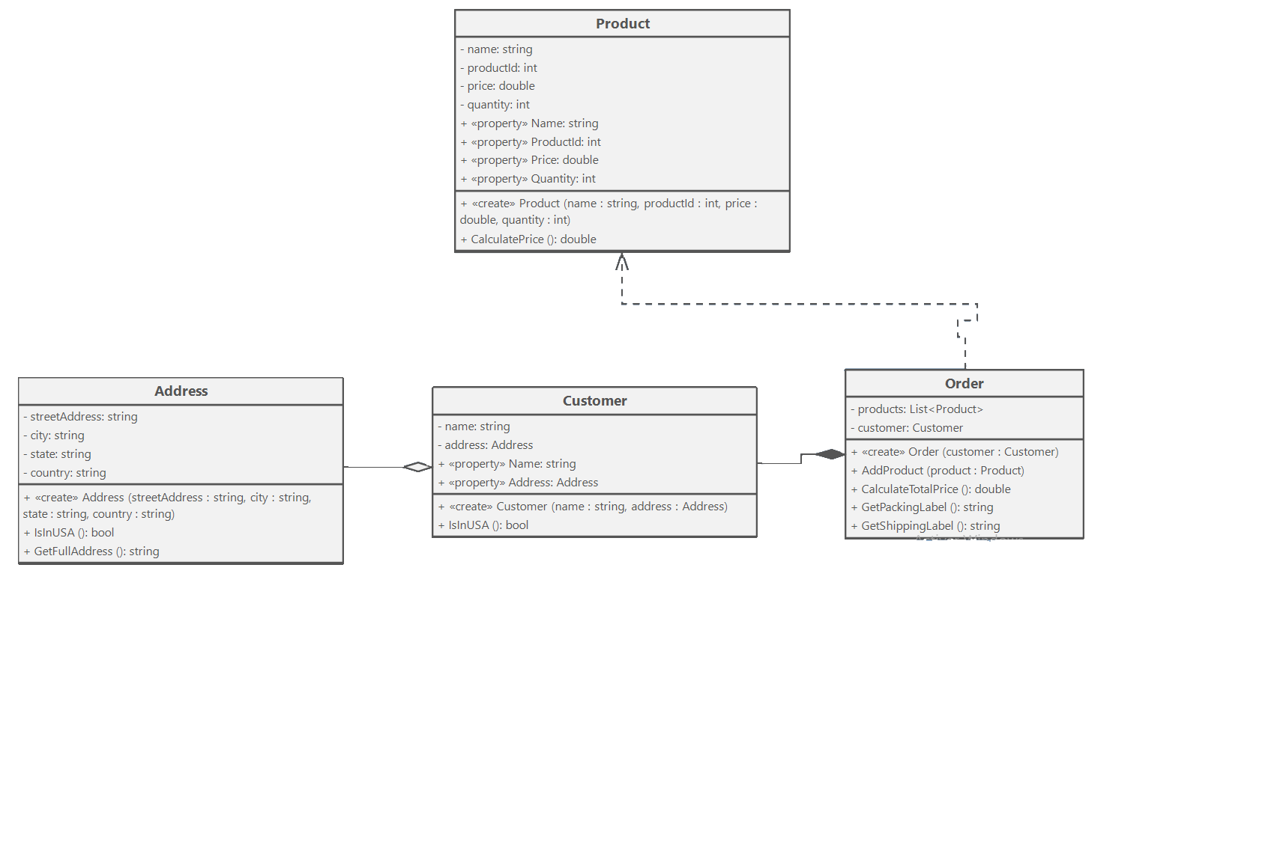Inheritance with Event Planning

FOUNDATION 4

Polymorphism with Exercise Tracking

